Ellis Island (1892-1954)
Some testimonies about seeing the Statue of Liberty upon arrival:
"We came by steerage on a steamship in a very dark place that smelt dreadfully. There were hundreds of other people packed in with us, men, women and children, and almost all of them were sick. It took us 12 days to cross the sea, and we thought we should die, but at last the voyage was over, and we came up and saw the beautiful bay and the big woman with the spikes on her head and the lamp that is lighted at night in her hand."
In other first-hand accounts of arriving at Ellis Island, a 79-year-old German man said of seeing the statue, “I thought she was one of the Seven Wonders of the World."
A man from Poland gushed, "The bigness of Mrs. Liberty overcame us. No one spoke a word for she was like a goddess and we know she represented the big, powerful country which was to be our future home."
Examinations and Tests on Ellis Island
Over 12 million immigrants came to America through Ellis Island in search of freedom and opportunity. They mostly came by steamship. Examinations and vaccinations of the immigrants needed to be done. Both immigrants and their baggage had to be disinfected before they could leave Ellis Island and reach New York. During busy periods, as many as 5,000 people each day would be checked. Each, in turn, had to undergo both physical inspection and extensive questioning before they were released. Doctors checked for more than 60 diseases (smallpox, yellow fever, measles, …) and disabilities (G for goiter, K for hernia, L for lameness, S for senility, ...) that might disqualify them from entry into the United States. Those suspected of being afflicted were marked with chalk and detained for closer examination. All immigrants were checked closely for trachoma, a contagious eye condition that caused more detainments and deportations than any other ailment. To check for trachoma, the examiner used a buttonhook to turn each immigrant’s eyelids inside out, a procedure remembered by many as particularly painful and terrifying. The final test was to answer 29 questions. For the majority of people, the procedure took between three and five hours. Approximately 20 percent of immigrants were held for medical treatment or for a legal hearing. Those two percent denied entry were sent back across the ocean at the steamship line's expense.
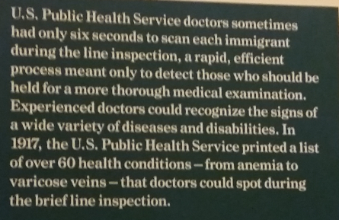

Personal Questions  - How old are you?  - Are you married or single?  - What is your occupation?  - Are you able to read and write?  - What country are you from?  - What is your final destination in America?  - Who paid for your passage?  - Are you meeting a relative here in America? Who?  - Have you been in a prison, almshouse, or institution for care of the insane?  - Are you a polygamist? An anarchist?  - Are you coming to America for a job? Where will you work? | Knowledge Questions  - Who was the first President of America?  - What are the colors of our flag?  - How many stripes are on our flag? How many stars?  - What is the 4th of July?  - What is the Constitution?  - What are the three branches in our government?  - Which President freed the slaves?  - Can you name the 13 original Colonies?  - Who signs bills into law?  - Who is the current President of the United States?  - What is America’s national anthem called?

Anarchists were denied admittance into the United States as of 1903. On April 17, 1907, an all-time daily high of 11,747 immigrants received was reached. That year, Ellis Island experienced its highest number of immigrants received in a single year, with 1,004,756 arrivals.
In 1918, a literacy test was introduced. Those over the age of 16 who could not read 30 to 40 test words in their native language were no longer admitted through Ellis Island.
Jigsaw examples:




Knox, a physician, developed the Feature Profile Test, which he administered from 1912 to 1916. The puzzle represented a progressive reform of sorts. Before it, the public health service measured intelligence with traditional I.Q. tests, whose questions required cultural and linguistic knowledge that many immigrants did not have, causing perfectly intelligent people to test as “imbeciles”. The Feature Profile Test relied on more universal knowledge—around the world, noses and ears are in the same places.
The Eyelid Lift
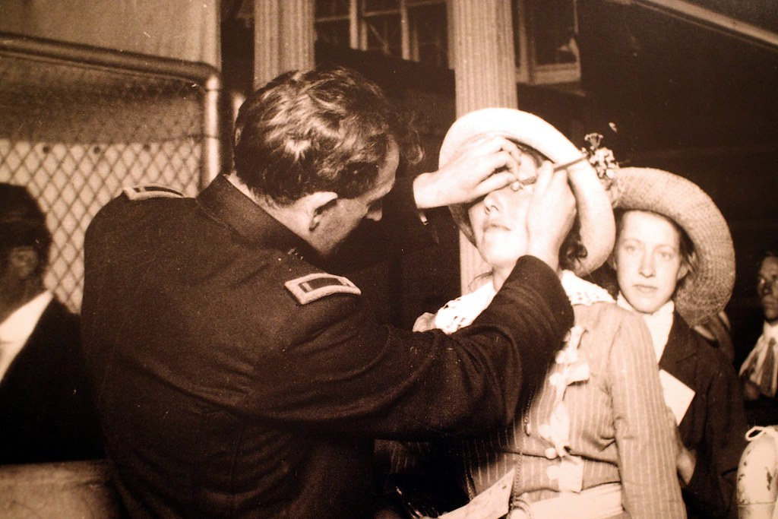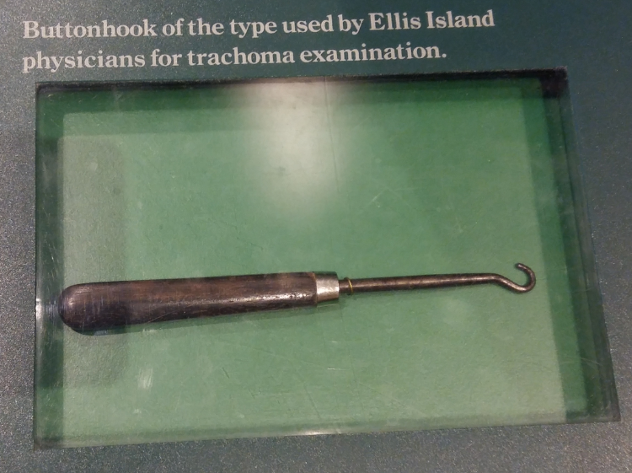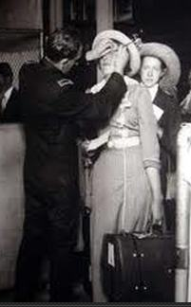
Trachoma is an easily spread infection of the eye. Repeated occurrences scar the upper eyelid, eventually turning it inward. The eyelashes then scratch the cornea, leading to blindness.

The different steps to authorization:
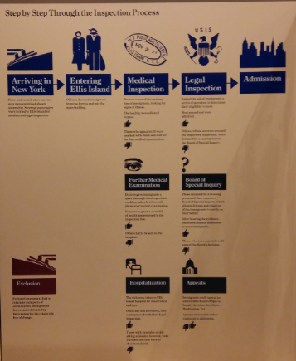
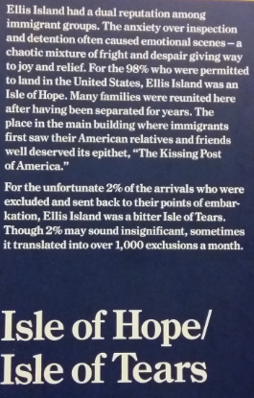

Some famous people who came through Ellis Island

Many famous figures passed through Ellis Island, some leaving their original names behind on their entry into the U.S.
Israel Beilin, better known as composer Irving Berlin, arrived in 1893.
Lily Chaucoin arrived from France to New York in 1911 and found Hollywood stardom as Claudette Colbert.
Some were already famous when they arrived, such as Carl Jung and Sigmund Freud (both 1909), while some, like Charles Chaplin (1912) would make their name in the New World.

Other famous Ellis Island immigrants:
Nicola Sacco and Bartolomeo Vanzetti from Italy.
Elia Kazan, movie director from Turkey.
Isaac Asimov, sci fi writer from Russia.
Cary Grant, actor from England.
Al Jolson, first actor to talk in a movie from Lithuania.
Lucky Luciano, mobster boss from Italy.
Harry Houdini, magician from the Austro-Hungarian Empire.
Arthur Stanley Jefferson, actor from England remembered for his role as Stan Laurel.

